**Project 1**

Running the program with mode 0 that means read data from files for character-by-character takes more time and CPU time than reading line-by-line. Because it read every letter of words so it takes more time.

Running the program in Linux

I got these outputs:

As you can see time and CPUtime in Character-by-character are more than time and CPUtime in Line-by-line.

the time from 'ftime' for Char-by-Char is 0.022 seconds

the time from 'getCPUtime' for Char-by-Char is 0.020 seconds

the time from 'ftime' for Line-by-Line is 0.010 seconds

the time from 'getCPUtime' for Line-by-Line is 0.010 seconds

Running the program in Visual Studio 2010

I got these outputs:

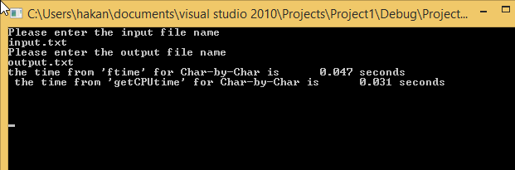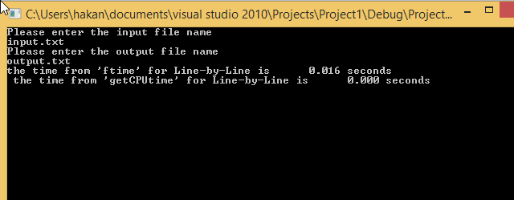

As you can see reading line-by-line is better. It takes less time.

I used the same code for both operating systems that are Linux and Microsoft.

These codes work for both system.